Green Land Project Extension

In propose work author has used all traditional ML algorithms and have not employed any deep learning algorithms such as CNN or LSTM. So as extension we have employed advanced DL algorithm called CNN2D (Convolution Neural Network 2 Dimension) which is known for optimizing training features using multi layers and neurons which help this algorithm in gaining better accuracy.

In below screen showing extension output

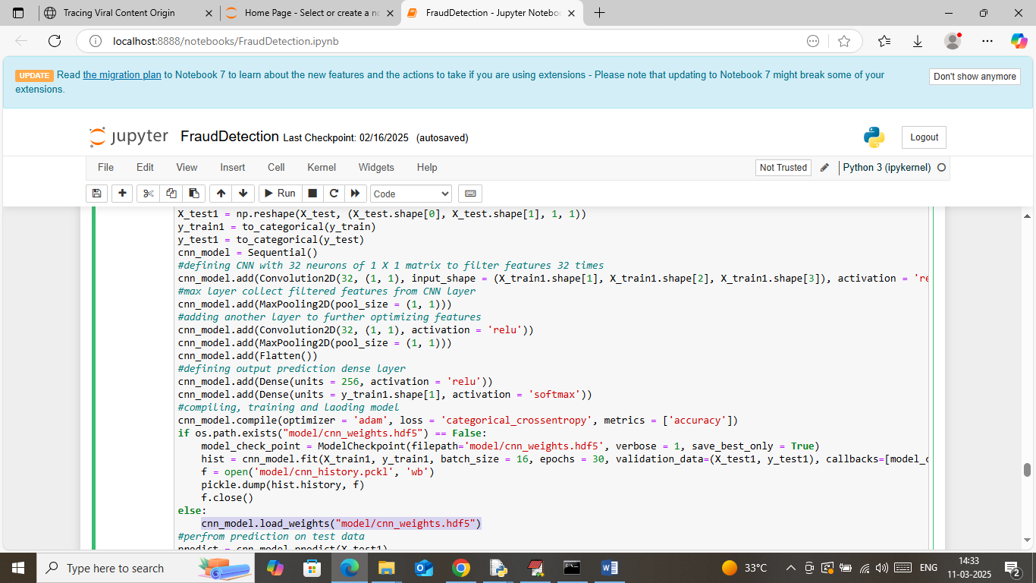

In above screen training and loading extension CNN2D algorithm and after execution will get below output

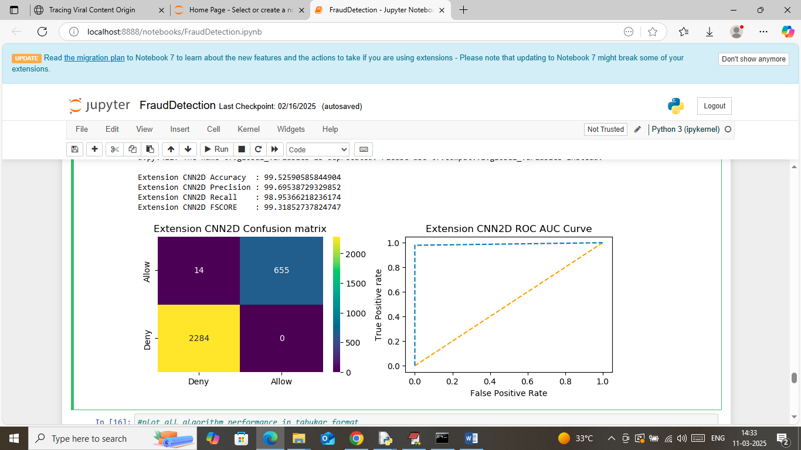

In above screen extension CNN2D got 99.52% accuracy and can see other metrics also

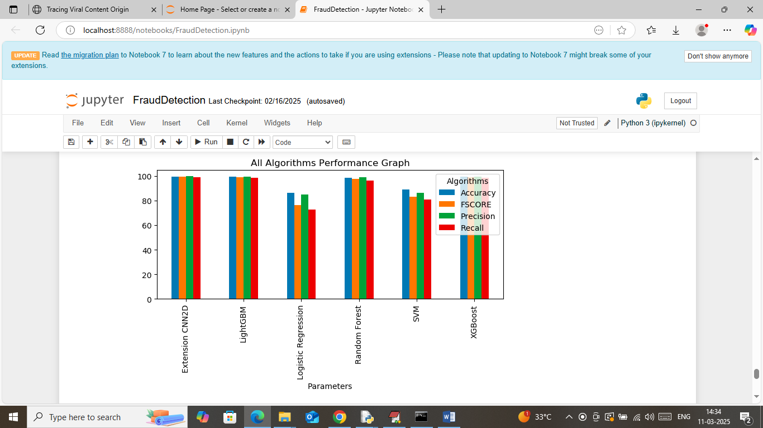

In above screen showing all algorithms comparison performance along with extension CNN2D

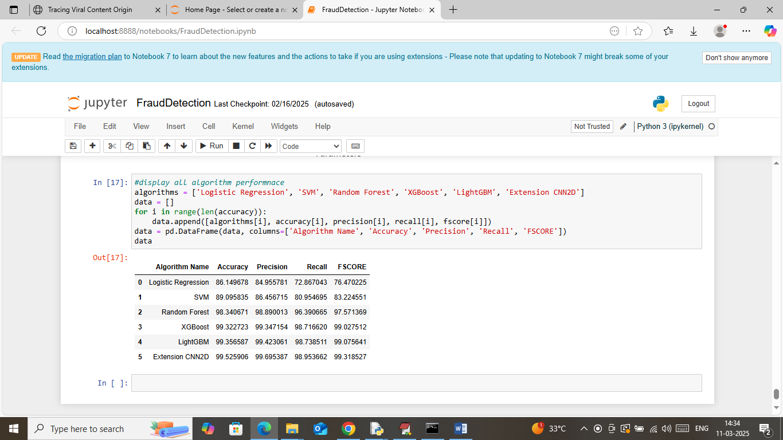

In above screen in all algorithms performance table can see extension CNN2D got high accuracy.